EL5600-04P/08P EPON OLT User Manual

Installation Configuration Manual

- Product Introduction
- Specifications and Features
- Installation Preparations
- Installation
- Booting and Configuration
- Software Updating
- Fault Treatment
- Optional Interface Module
- Appendix RJ-45 Connector
Content

Chapter 1 Product Introduction - 1 -
1.1 Brief introduction of EL5600-04P/08P EPON OLT - 1 -
1.2 The typical application of EL5600-04P/08P EPON OLT - 1 -
Chapter 2 Specifications and Features - 2 -
2.1 Appearance of EL5600-04P/08P EPON OLT - 2 -
2.2 The front board of EL5600-04P/08P EPON OLT - 2 -
2.2.1 The Picture of the Front Board - 2 -
2.2.2 Port Attribute of EPON OLT SFP - 4 -
2.3 EL5600-04P/08P EPON OLT back board - 4 -
2.3.1 The Picture of the back board - 5 -
2.3.2 Optional power module of power extended slot - 5 -
2.4 System Features of EL5600-04P/08P EPON OLT - 5 -
Chapter 3 Installation Preparation - 9 -
3.1 Security Notice - 9 -
3.2 Examine Installation Location - 9 -
3.2.1 Temperature/Humidity - 10 -
3.2.2 Neatness - 11 -
3.2.3 Static Free - 11 -
3.2.4 Anti-jamming - 12 -
3.2.5 Anti-lightning - 13 -
3.3 Tools for Installation - 13 -
Chapter 4 Installation - 15 -
4.1 Installation Step - 15 -
4.1.1 Install to the Rack - 15 -
4.1.2 Install to the Platform - 16 -
4.2 Connect to Ground - 17 -
4.2.1 AC power Installation - 17 -
4.2.2 DC power Installation - 17 -
4.2.3 Connect to Ground - 18 -
4.3 Connect to Switch Console Port - 18 -
4.3.1 Console Cable - 18 -
4.3.2 Connect to Console Port - 19 -
4.4 Check after the Installation - 20 -
Chapter 5 Booting and Configuration - 21 -
5.1 Local terminal configuration - 21 -
5.1.1 Configuration environment - 21 -
5.1.2 Connect configuration cable - 21 -
5.1.3 Configure terminal parameter - 21 -
5.2 Booting - 27 -
5.2.1 Examine before the power on - 27 -
5.2.2 Booting - 28 -
Chapter 6 Software Upgrade - 29 -
Chapter 7 Troubleshooting - 31 -
7.1 Power System Failure - 31 -
7.2 Configuration System Failure - 31 -
7.2.1 Troubleshooting on No Displaying - 31 -
7.2.2 Troubleshooting on displaying Illegible Characters - 32 -
8.1 RJ-45 Connector - 33 -
8.2 Make the Cable - 35 -
Picture 8-5 Make crossing reticle - 36 -

Product Introduction
  - Brief introduction of EL5600-04P/08P EPON OLT
EL5600-04P/08P is designed for EPON OLT independent development of the cassette products by GCOM, it owns 4/8 GEPON ports (EL5600-04P has four GEPON ports) and 8 Gigabit COMBO Ethernet port, The height is only 1U for easy installation and space saving. Each PON supports up to 64 terminals, the whole device supports up to 512 ONUs under full configuration. EL5600 adopts advanced technology to support SLA and DBA to keep strong function on the Ethernet and QoS features. EL5600 is applied for commercial and grid network digital management to provide perfect, smart, strong, advanced, professional solutions for “automatic distribution” and “electricity information collection” in the implemented project for the national grid.
  - The typical application of EL5600-04P/08P EPON OLT
The typical network of EL5600-04P/08P shows as below:
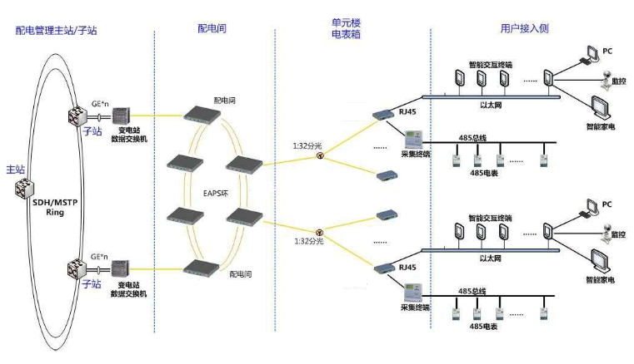

Specifications and Features
  - Appearance of EL5600-04P/08P EPON OLT
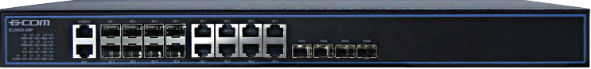
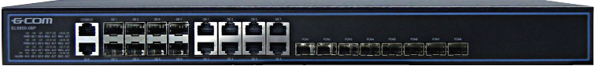
        - Appearance of EL5600-04P/08P EPON OLT
  - The front board of EL5600-04P/08P EPON OLT
    - The Picture of the Front Board
Front panel array of EL5600-04P/08P EPON OLT as below, front panel includes 8*10/100/1000BASE-TX Combo port and 8*PON port, several LED indicators, one console and one AUX:
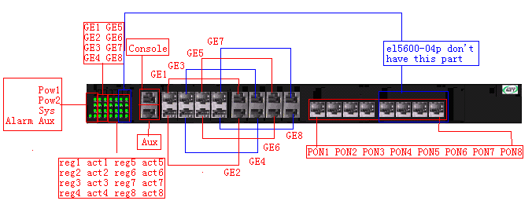
        - The picture of the front board of EL5600-04P/08P OLT
The meaning of LED indicator in front board are in the following table 2-1：
      - Indicator in front board of EL5600-04P/08P EPON OLT
Indicator | Panel Indicator | Status | Meaning
System operating indicator | SYS | Always flick | System operates normal
System operating indicator | SYS | Always on or Always off | System works failure
Power indicator | PWR1, PWR2 | Always on | OLT is on
Power indicator | PWR1, PWR2 | Always off | OLT is off
Port indicator | Link/Act | On | Connect
Port indicator | Link/Act | Off | Disconnect
Port indicator | Link/Act | Flick | Send or receive data
PON indicator | REG | On | ONU register at PON port
PON indicator | REG | Off | No ONU register at PON port
PON indicator | ACT | On | This port is receiving /sending data
PON indicator | ACT | Off | This port isn’t receiving /sending data

    - Port Attribute of EPON OLT SFP
Front panel of EL5600-04P/08P OLT has 4/8*PON OLT SFP and 8*1000M Combo port.
      - Description of optional module of EPON OLT SFP interface
SFP Module Name | Central wavelength | Connector type of user’s fiber interface | Interface fiber specification | The max transmission distance
SFP-EPON-LH10 | Receive:1310nm;  Send:1550nm | LC | Single-mode fiber | 10km
SFP-EPON-LH20 | Receive:1310nm;  Send:1550nm | LC | Single-mode fiber | 20km
      - Description of optional module of GE Ethernet SFP interface
SFP Module Name | Central wavelength | Connector type of user’s fiber interface | Interface fiber specification | The max transmission distance
SFP-GE-SX-MM850 | 850nm | LC | Multi-mode fiber | 550m
SFP-GE-SM1310-LH10 | 1310nm | LC | Single-mode fiber | 10km
SFP-GE-SM1310-LH20 | 1310nm | LC | Single-mode fiber | 20km
SFP-GE-SM1310-LH40 | 1310nm | LC | Single-mode fiber | 40km
SFP-GE-SM1550-LH40 | 1550nm | LC | Single-mode fiber | 40km
SFP-GE-SM1550-LH60 | 1550nm | LC | Single-mode fiber | 60km
Description：The type of GE SFP module will update with the time changing. Please consult New Greennet sales.
    - Console
Optiway EL5600-08P（04P）OLT provides EIA/TIA-232 console to configure .

Table 2-4 Optiway EL5600-08P（04P）OLT Console
Attribute | Asynchronous serial interface
Interface | RJ-45
Standard | Asynchronous EIA/TIA-232
Baud rate | 9600bit/s

  - EL5600-04P/08P EPON OLT back board
    - The Picture of the back board
EL5600-04P/08P EPON OLT back boardis as following: 1 AC 220V power interface. This device can change power modules based on customer requirement., it can configure AC or DC.
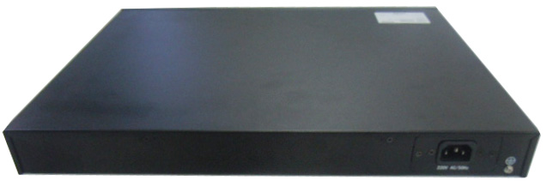
        - Backboard of EL5600-04P/08P EPON OLT
1――2power extended slots；
2――grounding pole；
 Caution： EL5600-04P/08P EPON OLT can support AC or DC -48V
  - System Features of EL5600-04P/08P EPON OLT
      - System feature of EL5600-04P/08P EPON OLT
Item | EL5600-04P/08P
Proccessor | MIPS32
BOOT ROM | 512K
DDR | 128M
FLASH | 8M
Size (L*W*H) | 1RU, 442mm×315mm×44mm
Weight | <5kg
Power Input | AC: 176V～265V AC 47/63Hz  DC: -36V～-72V DC
Maximum power | <52W
Interface | 4/8*PON,8*Combo( 10BASE-T,100BASE-TX,1000BASE-T;100BASE-FX and1000BASE-X),1*console,1*debug port
Switching mode | Store-and-forward （storage transmission）
Switching capacity | 16G
Support standard | IEEE 802.3ah EPON  IEEE802.3(10Base-T)  IEEE802.3u(100Base-TX)  IEEE802.3z（1000BASE-X）  IEEE802.3ab（1000Base-T）  IEEE802.1Q(VLAN)  IEEEE802.1d(STP)  IEEEE802.1W(RSTP)  IEEEE802.1S(MSTP)  IEEE802.1p(COS)  IEEE802.1x(Port Control)  IEEE802.3x（flow-control）  IEEE802.3ad(LACP)  Each OLT interface supports at most 64 ONU；  Transmission distance of each OLT is at most 20Km
Layer 2 function | VLAN,QinQ,link convergency, broadcast strom control  Support at most 4096 VLAN；  16K MAC address; Bandwidth control
Aggregation group | 127 groups, each group has over 8 members
ACL/QoS | Support ingress, engress ACL  Backpressure flow control (half duplex)  IEEE 802.3x flow control（duplex）  IEEE p802.1p, CoS  WRR,SP and FIFO queue scheduling algorithm  802.1P/DSCP priority Mark/Remark  Uplink and downlink speed limitation based on each ONU  Support traffic classification of DBA and SLA  Support remark priority , packet redirection based on traffic
Security | Limit quantity of maximum user at each port  Port violation  Packe storm control  ACL access control based on data stream  Encrytion of PON port transmitting data  Support 802.1X authentication
Multicast | IGMP v1/v2/v3  IGMP Snooping  Multicast VLAN; controlled multicast
Port mirror | Support
Configuration and management | SNMP  GreenNet NMS；  CLI, Web, SNMP, TELNET,cluster etc.  RMON v1, 1,2,3,9 groups  SSHv1/v2  Software and bootrom upgrade by TFTP and FTP  Local server syslog to record system log  Chinese/English command prompt  Ping and traceroute  Debug
Lightning | Service port has lightning protection
Maintenance | Telnet remote maintenance
Temperature | 0℃～50℃
Humidity | 5%～95%

Chapter 3 Installation Preparation

3.1 Security Notice

To avoid device damaging and bodily injured caused by unsuitable operation, please follow these notices:
- Before cleaning switch, pull out the plug of switch. Do not wipe it with wet cloth and liquid.
- Do not locate switch near water or humid place, and prevent water and humidity entering switch.
- Do not locate switch on unstable case or desk. Falling may cause severe damage to switch.
- Keep the ventilation of the room and the switch.
- Switch can work normally under correct power pressure. Please affirm the power pressure of switch is the same as that marked.
- To avoid the danger of electricity attacking, do not open the cabinet shell though the switch is power off.

3.2 Examine Installation Location
S8600-04 EPON OLT must use indoor, no matter install in the cabinet or put the platform directly, it should ensure below conditions ：
  - Make sure there is space between the wind inlet and vents to hot dissipation.
  - Make sure the cabinet or platform has the good vents dissipation system.
  - Make sure the cabinet or platform is firmed to bear the device weight.
  - Make sure the cabinet or platform is connected to the ground.
To ensure the device works normally and prolong the service life, the installation environment also need to fulfill the below requirements.
    - Temperature/Humidity
To guarantee normal working and life span of the switch, certain temperature and humidity can be maintained in the equipment room. If the humidity is too high, the insulating of insulating material may be not good, even creepage and sometimes may cause the change of mechanical performance and rustiness of metal parts. If the related humidity is low, the insulated gasket will be shrinkable which will cause the looseness of captive screw. In the dry climate, electrostatics may be caused which is harmful for the CMOS circuit of switch. The higher the temperature is, the more dangerous it is. It will greatly reduce the reliability of the switch, and long-term high temperature will affect the life span of the switch. Over-high temperature may accelerate the aging of the insulated materials.
Table 3-1 The temperature and humidity requirements
Temperature |  | Humidity
Long-term | Short-term | Long-term | Short-term
15℃-30℃ | 0℃-50℃ | 40%-65% | 10%-90%
 Note:
- short-term means working no more than 48h less than 15 days a year；
- The critical working environment means the possible temperature and humidity when there is no air-conditional. It should be recovered in 5h.
    - Neatness
Dust is harmful for the operation of the switch. The dust in the room fell on the equipment may cause the absorption of the electrostatics, which may influence the life span of the switch and cause the communication failure. The requirement for the dust and the grin size is as following.

Table 3-1 The requirement for the dust in switching room
The maximum diameter (um) | 0.5 | 1 | 3 | 5
The maximum thickness (the number of grain per m³) | 1.4×10⁷ | 7×10⁵ | 2.4×10⁵ | 1.3×10⁵

Besides dust, switching room also strictly requires the content of salt, acid and sulfide. This harmful gas may accelerate the rusting and aging of same parts. Such harmful gas must be prevented as SO2, H2O, NO2, NH3 and CL2. The restricted value is as following:
Table 3-2 The limitation of harmful gas
Gas | Average (mg/m³) | Maximum (mg/m³)
SO2 | 0.2 | 1.5
H2S | 0 | 0.03
NO2 | 0.04 | 0.15
NH3 | 0.05 | 0.15
Cl2 | 0 | 0.3
    - Static Free
8600 series OLT makes a lot of consideration in anti-static, but static electricity over a certain tolerance limit will disruptive the circuit, even the whole switch.
  - In the network connected by the switch, electrostatic induction is mainly from two aspects: the outdoor high-voltage power lines, lightning and other external electric field; indoor environment, flooring materials, the whole structure of the internal system. In order to prevent electrostatic damage, we should:
Equipment and floor ground connection;
Anti-Indoor dust;
Maintain proper temperature and humidity conditions;
When touch the circuit board, user should wear anti-static wrist strap and overalls;
The demolition of the circuit board face up on an anti-static working surface or an anti-static bag;
Avoid direct touching circuit components.

3.2.4 Anti-jamming
Switch may receive the jamming from exterior system. This jamming influences devices through capacitance coupling, inductance coupling, electromagnetic wave radiation, common impedance (including grounding system) coupling, and conducting wire (power wire, cable and outputting wire). Pay attention to the followings:
- AC power supply uses TN system and the plug adopts single-phase three-line power supply with protecting earth wire (PE) for filtering circuit to filtrate the jamming of electricity network.
- The location the switch works must be far away from high power wireless launcher, radar launcher and high frequency and current devices.
- Adopts electromagnetism shield when necessary, such as adopting shield cable to be interface cable.

3.2.5 Anti-lightning
8600 series OLT makes a lot of consideration in anti-lightning, but lightning over a certain tolerance limit will disruptive the circuit even the whole switch.
Users should:
- Ensure chassis is well connected to the ground
AC power outlet is well connected to the ground
  - Tools for Installation
Tools needed:
- Cross screwdriver
- Antistatic wrist strap
- Wire stripper
Cable needed:
- Power cable
- Console cable
- RJ-45 connector reticle
Device needed:
- Configuration terminal (can be PC)
Caution：S8600-04 EPON OLT doesn’t provide installation tools which are prepared by user ..

Chapter 4 Installation
Caution：There is an anti-dismantle seal remarked New Greennet on the installation screw outside the case. When the agents maintain the device, it is required that seal is entire. So before user opens the device, please get the permit from local agent, or user will take the responsibility with unauthorized operation maintenance.
  - Installation Step
    - Install to the Rack
S8600-04 EPON OLT can install on the rack , the process is as below:
Step 1: Examine grounding and stability of the cabinet. Use screw to fasten hanger to the two sides of the front board and back board of the switch；
Step 2: Locate switch on the salver of the cabinet. Move it to the suitable location along with the slide of the switch. Keep some space between switch and the slide.
Step 3: Fasten hanger to the fixed slide of the cabinet to guarantee the bracket of each slot and hanger of the switch are fastened to the cabinet.
Step 4: The hanger of the switch is not used to bear the load but fasten. Switch is installed in a 19” cabinet. There must be slides in chassis (fastened in frame) to support switch.

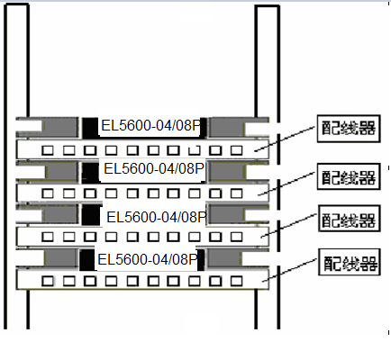

Figure 4-1 S8600-04 EPON OLT installation
Caution：The fixed angle iron is only for fixation not for load-bearing. The device install on the cabinet, slide (fix on the cabinet)under the device is to bear the weight.
    - Install to the Platform
At more situations, users always put the device to the clear platform. The operation is simple, please be noted of below steps:
  - Make sure the platform is stable and good connected to the ground
  - Leave 10cm space for the heat dissipation around the device
  - Don’t put the heavy things to the device.
  - Connect to Ground
S8600-04 EPON OLT adopts hot swappable power box. It also supports AC and DC power backup for each other mixed-mode.
There are two kinds of power box, AC and DC, the range of power is
AC 100V～ 240V
DC –36V~–72V
    - AC power Installation
      - The input range of AC
100V～240V,50/60Hz AC
      - Connect to the AC power cord
Step 1：Insert AC power box into EL8600-04 back slot.
Step 2：Plug the power cord into outlet on the rear panel, the other end insert into the AC power outlet.
    - DC power Installation
    - The input range of DC
-36V～-72V, DC
    - Connect to the DC power cord
Plug the DC power cord into outlet on the rear panel, the other end red wire inserts into the DC power positive electrode, black wire inserts to the DC power negative electrode.
    - Connect to Ground
Caution：The device well-connected can protect switch from lightning and jamming, user must correctly connect the ground carefully.
S8600-04 EPON OLT power supply is connected with communication noise filter, which is directly connected to the chassis carefully, making induction, leakage electricity can safely into the earth, and improves overall EMI characteristics. For the external network connection, such as the E1 interface, PSTN and other cable series with the lightning voltage, ground can provide protection.
Use a thick wire and connect the points with the earth, grounding resistance is less than 4 ohms. If the switch is installed in the cabinet, the cabinet also has to take the land required.
  - Connect to Switch Console Port
    - Console Cable
Console cable is a shield cable of 9 cores. One end is crimped RJ-45 connector, which is inserted to Console interface; the other end is a connector with DB-9 (holes). The Console cable is as the following picture:
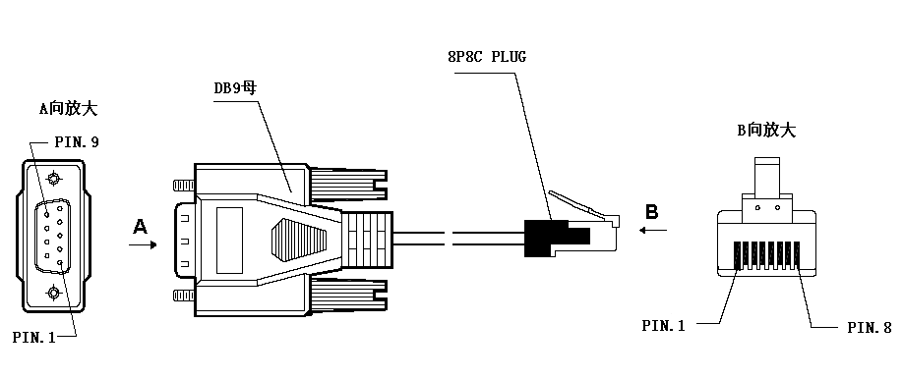
Picture 4-2 Console cable

Table 4-1 Console cable connection
RJ45 | Signal | Direction | DB-9
1 | CTS | → | 8
2 | DSR | → | 6
3 | RXD | → | 2
4 | GND | - | 5
5 | GND | - | 5
6 | TXD | ← | 3
7 | DTR | ← | 4
8 | RTS | ← | 7
    - Connect to Console Port
After configuring the device, the steps of cable connection as below:
Step 1：Put DB-9 to the configured host or console ；
Step 2：Connect RJ-45 to console
Caution：Please recognize the interface identification to avoid inserting the other interfaces by mistake.
  - Check after the Installation
  - Check the selected power is the same as identification power or not.
  - Check the ground wire is connected or not
  - Check the console , power input cable are connected or not.

Chapter 5 Booting and Configuration
Caution：Optiway EL5600-06 EPON OLT can provide two ways of configuration for users:
First: Local terminal configuration. Terminal (can be PC) connects to the Console by serial interface；
Second: Terminal Telnet configuration. Configuration terminal connects to device by IP network. Pay attention to configure IP address, net mask before using Telnet terminal.
  - Local terminal configuration
    - Configuration environment
Use configuration interface cable connect Console interface to terminal (such as PC).
    - Connect configuration cable
Step 1: Connect DB-9 connector to PC or serial interface of terminal.
Step 2: Connect RJ-45 to Console of the switch.
    - Configure terminal parameter
Step 1: Boot PC and run terminal emulation program (such as hyperterminal in Windows).
Step 2: Configure terminal parameter (take the configuration of parameter ofhyperterminal in Windows 2000 as an example). Parameters are: baud rate is “9600”, data bit is “8”, and parity check is “none”, stop bit is “1”, flow control is “none”, and choose terminal emulation as “auto-detect”. The configuration is as following:
Click “start”-“program”-“accessory”-“communication”-“hyperterminal” to set up new connection. System will display interface as following. Input the name of the new connection in “name”, such as EPON.
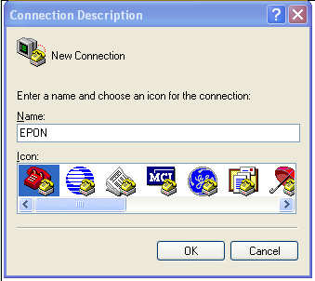
Picture 5-1 Explanation of hyperterminal connecting interface
Click [yes] to the interface [connecting to] as following. Choose serial interface used by connection in “use in connection”.
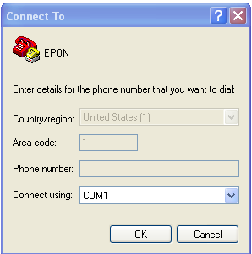
Picture 5-2 Configuration of using serial interface in hyperterminal
After choosing serial interface, click [yes] to display corresponded serial attribution interface as following. Configure baud rate to be “9600”, data bit to be “8”, parity check is “none”, stop bit is “1”, flow control is “none”.
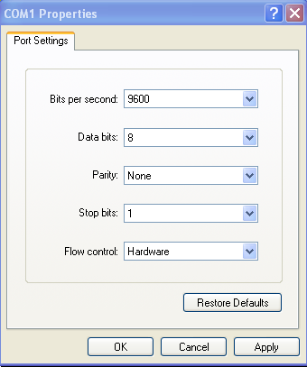
Picture 5-3 Serial parameter configuration
Click [configure] in hyperterminal attribution to configure serial interface attribute as following:
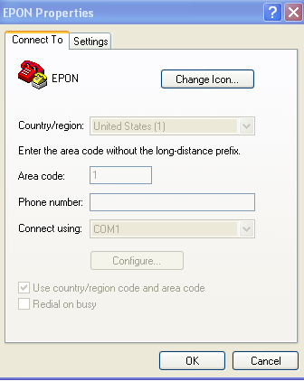
Picture 5-4 configure serial interface attribute in hyperterminal attribution interface
After configuring serial parameter, click [yes] to enter hyperterminal interface as following:
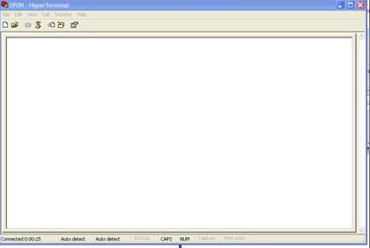
Picture 5-5 hyperterminal window
Choose （attribution） in typerterminal window to enter attribution window. Click [configure] to enter attribution configuration window (as in following picture). Choose terminal emulation as “auto-detect”, then click [yes].

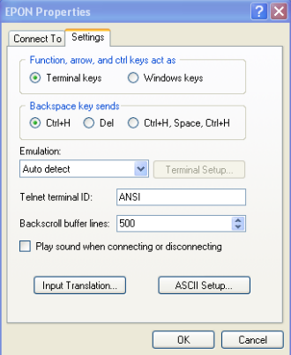
Picture 5-6 Configuration of terminal emulation in attribution configuration
  - Booting
    - Examine before the power on
Examine as following before the power of Optiway EL5600-06 EPON OLT is on：
- The correct connection of power wire
- The consistency of the power supply and the power that switch needed
- The correct connection of configuration cable. The terminal or PC for configuration has been configured.
    - Booting
After the power is on, followings will be displayed:
Username(4-32 chars)：
Input username and press enter button. The prompt of inputting password is as following:
Password(1-15 chars)：
After inputting password, followings are displayed:
Optiway>
At this time, user can check and configure system information of device.

Chapter 6 Software Upgrade
General software upgrading uses serial interface which is very slow, cost long time and inconvenient. S8600-04 EPON OLT introduces xmodem, tftp and ftp to realize the convenience of software upgrading and file downloading. Optiway EL5600-06 EPON OLT can upgrade application program on line, load configuration file by xmodem, tftp and ftp, and also upload configuration files by xmodem, tftp and ftp.

1. Upload configuration file through TFTP（refer to software configuration manual）

2. Download configuration file through TFTP（refer to software configuration manual）

3. Download application file through TFTP（refer to software configuration manual）
Download application file through TFTP. The command is:
load application tftp tftp-server filename
Download application file through TFTP:
Step 1: Enable TFTP server and configure download destination path；
Step 2: Imput TFTP download command.
Example: Download application program app.arj from IP address 192.168.0.100. Enable TFTP server and configure download destination path. Configure it in privileged mode:
Optiway#load application tftp 192.168.0.100 app.arj
There will be displaying as following if succeed：
Application file has been downloaded via tftp successfully.
The new application will not be effective until the device is rebooted.
Caution：The new application will not be effective until the device is rebooted.

Chapter 7 Troubleshooting

7.1 Power System Failure
S8600-04 EPON OLT can check the power system failure according to the power indicator on the front board: when the power system works normally, the power indicator keeps on; if it is off, please examine as following:
- The correct connection of power wire.
- The matching of power supply of switch and power required.
  - Configuration System Failure
After The power of S8600-04 EPON OLT is on, if the system works normally, the booting information will be displayed in configuration terminal; if there is failure in configuration system, it will display nothing or illegible characters.
    - Troubleshooting on No Displaying
After the power is on and if the configuration terminal displays nothing, please examine the device as following:
- The power works normally.
- The correct connection of Console cable
If there is no problem in above examination, maybe there is something wrong with the parameter configuration of the terminal (such as hyper terminal) or the configuration cable.

7.2.2 Troubleshooting on displaying Illegible Characters
If illegible characters are displayed, parameter configuration of terminal (such as hyper terminal) is incorrect. Please affirm parameter configuration of terminal (such as hyper terminal): baud rate is “9600”, data bit is “8”, and parity check is “none”, stop bit is “1”, flow control is “none”, and choose terminal emulation as “auto-detect”.

Chapter 8 Appendix RJ-45 Connector

8.1 RJ-45 Connector
1000Base-TX interface and debug network interface of S8600-04 EPON OLT uses RJ-45 connector.
Picture 9-1 describes the plug of standard RJ-45, connector and function of each pin of RJ-45 in each mode
Picture 9-2, 9-3 describe the connecting of parallel reticle and crossing reticle.
Table 9-1 describes the function of each pin of RJ-45 in MDI mode;
Table 9-2 describes the function of each pin of RJ-45 in MDI mode.
Picture 8-1 Standard RJ-45 plug and connector
Picture 8-2 Parallel reticle
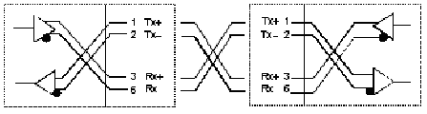
Picture 8-3 Crossing reticle
Table 8-1 Pin distribution of RJ-45 MDI interface
Pin number | Signal | Function
1 | TxData+ | Sending data
2 | TxData- | Sending data
3 | RxData+ | Receiving data
4 | Reserved
5 | Reserved
6 | RxData- | Receiving data
7 | Reserved
8 | Reserved
Table 8-2 Pin distribution of RJ-45 MDIX interface
Pin number | Signal | Function
1 | RxData+ | Receiving data
2 | RxData- | Receiving data
3 | TxData+ | Sending data
4 | Reserved
5 | Reserved
6 | TxData- | Sending data
7 | Reserved
8 | Reserved

8.2 Make the Cable
Appendix picture 2 is the example of making Ethernet cable of RJ-45 connector by using categories 5 twisted-pair.
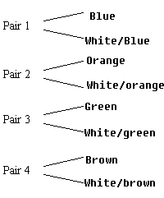
Picture 8-4 The picture of categories 5 twisted-pair
Categories 5 twisted-pair consists of 8-core filament with the color on the insulated layer being grouping sign. Usually, it uses a single color and single color with white to be a pair of standard, and sometimes uses color points to be a pair of sign. Here, take the former as an example.
Categories 5 twisted-pair consists of 8-core filament with the color on the insulated layer being grouping sign. Usually, it uses a single color and single color with white to be a pair of standard, and sometimes uses color points to be a pair of sign. Here, take the former as an example.

SIDE1 SIDE 1 SIDE 2
1 2 3 4 5 6 7 8 1＝white/orange 1=white/orange
2＝orange 2＝orange
3＝white/green 3＝white/green
4＝blue 4＝blue
5＝white/blue 5＝white/blue
6＝green 6＝green
7＝white/brown 7＝white/brown
1 2 3 4 5 6 7 8 8＝ brown 8＝brown

SIDE2
Picture 8-5 Make parallel reticle
SIDE1 SIDE1 SIDE2
1 2 3 4 5 6 7 8 1＝white/orange 1＝white/green
2＝orange 2＝green
3＝white/green 3＝white/orange
4＝blue 4＝blue
5＝white/blue 5＝white/blue
6＝green 6＝orange
7＝white/brown 7＝white/brown
1 2 3 4 5 6 7 8 8＝ brown 8＝brown

SIDE2

Picture 8-5 Make crossing reticle

